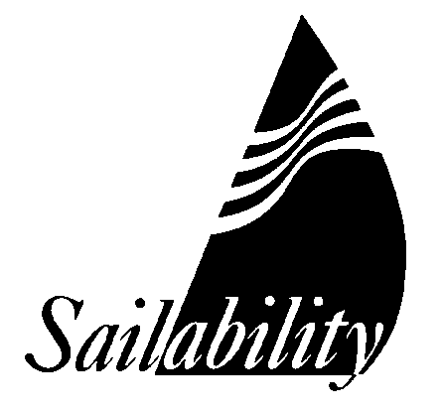
MEMBERSHIP (VOLUNTEER) APPLICATION

SAILABILITY NSW INC AND ITS BRANCH: MIDDLE HARBOUR
I hereby apply to become a member of Sailability NSW Inc. and Sailability Middle Harbour
In the event of my admission as a member, I agree to be bound by the rules of Sailability NSW Inc. and Sailability Middle Harbour for the time being in force and agree to abide by all decisions by a Committee Member with regard to activities at a Sailability event. My relevant personal details, which I understand are necessary to complete the membership database, are:
First Name: |  | Surname Name:
Address:
Mob. Phone: |  | Email: Date of Birth:
In case of emergency please contact:
Name: Mob.

I have a relevant medical condition: | YES/NO Details:
Do you have a First Aid qualification and if so, when does it expire?
If you have a Power Boat Licence, please provide your Licence Number:
I am happy for photos, in which I appear, to be used to promote Sailability Middle Harbour: |  |  | YES/NO
I heard about Sailability from:
Membership to Sailability NSW Inc. & Sailability Middle Harbour (to 30 June 2026): $ 10.00
Payment by bank transfer: BSB 032 199 Account Number: 331726
Ref: your surname

Sailing Experience (If any) ____________________________________________________________________________________________________________________________________________________________________________________________________________________________________

Other experience you think might be helpful as a volunteer:
____________________________________________________________________________________________________________________________________________________________________________________________________________________________________

Do you have Working With Children Number ? Yes / No
A Working With Children number (WWC number) is a requirement under state law. You can apply for one here: https://wwccheck.ocg.nsw.gov.au/Apply.

Signed: ___________________________ Date:________________

PLEASE EMAIL COMPLETED FORM TO SALLY O’NEILL saoneill2063@gmail.com

SMH REF NO (OFFICE USE ONLY) _______

