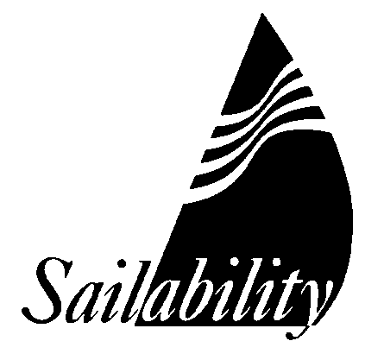
MEMBERSHIP (SAILOR) APPLICATION

SAILABILITY NSW INC AND ITS BRANCH: MIDDLE HARBOUR

Family Name: |  |  |  | Given Name:
Address:
Email: |  |  |  | Mobile Phone: Date of Birth
In case of emergency please contact:
Name: |  |  |  | Relationship to me:
Address:
Home Phone: |  |  | Work phone: |  |  | Mobile Phone:
My Carer (if not emergency contact) Name: Mobile:

The following personal information will assist Sailability Middle Harbour with organisation of events and future development planning:
Type of disability:
I need assistance: YES / NO |  | Type of assistance:
I have a family member / friend / carer to help me: YES / NO |  |  |  |  | I use a wheelchair: YES / NO
I have sailed before: YES / NO |  | Details:
I am happy for photos, in which I appear, to be used to promote Sailability Middle Harbour: |  |  |  |  | YES/NO
I heard about Sailability from:
Membership to Sailability NSW Inc. & Sailability Middle Harbour (to 30 June 2026 ): $50

Or $10 per sail

Payment by bank transfer: BSB 032 199 Account Number: 331726
Ref: your surname

Signature: |  |  |  |  |  |  | Date:

PLEASE EMAIL COMPLETED FORM TO SALLY O’NEILL saoneill2063@gmail.com

SMH REF NO (OFFICE USE ONLY) _______

